Insomnia

🌟 Definition
# Source: AI Source: Provided by: [Data Path: Persons Table -> ID Column: 1, Name_En Column: Motasem Essam] -> From: [ChatGPT] on [6/2/2026]
Insomnia is an API Development & Testing Platform used to design, test, debug, and manage APIs through a graphical user interface (GUI).
It is a popular alternative to Postman and is known for its simplicity and developer-friendly workflow.
Official website:
Insomnia

🎯 Purpose
# Source: AI Source: Provided by: [Data Path: Persons Table -> ID Column: 1, Name_En Column: Motasem Essam] -> From: [ChatGPT] on [6/2/2026]
Insomnia helps developers:
- Send API requests
- Test API responses
- Debug APIs
- Manage API collections
- Work with REST, GraphQL, gRPC, and WebSockets
- Generate API documentation
- Automate API workflows

🔢 Main Features of Insomnia

1. 📡 Send API Requests
# Source: AI Source: Provided by: [Data Path: Persons Table -> ID Column: 1, Name_En Column: Motasem Essam] -> From: [ChatGPT] on [6/2/2026]
🌟 Purpose
Send HTTP requests to APIs.
Supported methods:
- GET
- POST
- PUT
- PATCH
- DELETE
Example
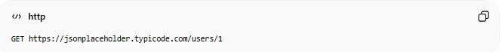
GET https://jsonplaceholder.typicode.com/users/1

2. 👀 View API Responses
# Source: AI Source: Provided by: [Data Path: Persons Table -> ID Column: 1, Name_En Column: Motasem Essam] -> From: [ChatGPT] on [6/2/2026]
🌟 Purpose
Display API responses in a structured format.
Example:
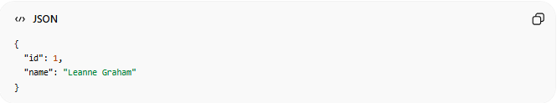
{
"id": 1,
"name": "Leanne Graham"
}

3. 🔐 Authentication & Authorization
# Source: AI Source: Provided by: [Data Path: Persons Table -> ID Column: 1, Name_En Column: Motasem Essam] -> From: [ChatGPT] on [6/2/2026]
🌟 Purpose
Test secured APIs.
Supported authentication methods:
- Bearer Token
- API Key
- OAuth 2.0
- Basic Auth
- JWT

4. 📂 Organize Requests
# Source: AI Source: Provided by: [Data Path: Persons Table -> ID Column: 1, Name_En Column: Motasem Essam] -> From: [ChatGPT] on [6/2/2026]
🌟 Purpose
Group related requests into collections or folders.
Example:
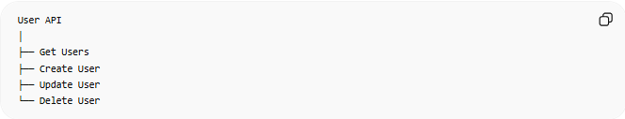
User API
│
├── Get Users
├── Create User
├── Update User
└── Delete User

5. 🌍 Environment Variables
# Source: AI Source: Provided by: [Data Path: Persons Table -> ID Column: 1, Name_En Column: Motasem Essam] -> From: [ChatGPT] on [6/2/2026]
🌟 Purpose
Store reusable values.
Example:
base_url = https://api.example.com
token = abc123xyz
Usage:
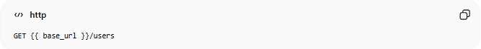
GET {{ base_url }}/users

6. 🧪 API Testing
# Source: AI Source: Provided by: [Data Path: Persons Table -> ID Column: 1, Name_En Column: Motasem Essam] -> From: [ChatGPT] on [6/2/2026]
🌟 Purpose
Validate API responses automatically.
Examples:
- Status code checks
- Response validation
- Data verification

7. 📊 GraphQL Support
# Source: AI Source: Provided by: [Data Path: Persons Table -> ID Column: 1, Name_En Column: Motasem Essam] -> From: [ChatGPT] on [6/2/2026]
🌟 Purpose
Work directly with GraphQL APIs.
Example:
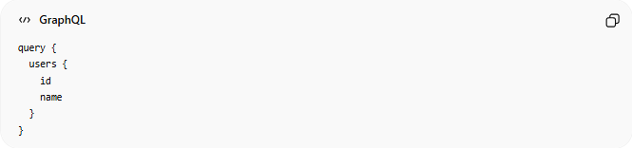
query {
users {
id
name
}
}

8. 🔄 gRPC Support
# Source: AI Source: Provided by: [Data Path: Persons Table -> ID Column: 1, Name_En Column: Motasem Essam] -> From: [ChatGPT] on [6/2/2026]
🌟 Purpose
Test gRPC services.
Common in:
- Microservices
- Cloud-native applications
- Backend systems

9. 🔌 WebSocket Support
# Source: AI Source: Provided by: [Data Path: Persons Table -> ID Column: 1, Name_En Column: Motasem Essam] -> From: [ChatGPT] on [6/2/2026]
🌟 Purpose
Test real-time APIs.
Examples:
- Chat applications
- Live notifications
- Real-time dashboards

10. 🤖 API Automation
# Source: AI Source: Provided by: [Data Path: Persons Table -> ID Column: 1, Name_En Column: Motasem Essam] -> From: [ChatGPT] on [6/2/2026]
🌟 Purpose
Create workflows and automate requests.
Example:
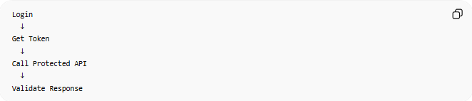
Login
↓
Get Token
↓
Call Protected API
↓
Validate Response

11. 📚 API Design & Specifications
# Source: AI Source: Provided by: [Data Path: Persons Table -> ID Column: 1, Name_En Column: Motasem Essam] -> From: [ChatGPT] on [6/2/2026]
🌟 Purpose
Work with API specifications such as:
- OpenAPI (Swagger)
- YAML
- JSON

🔗 How Insomnia Works
# Source: AI Source: Provided by: [Data Path: Persons Table -> ID Column: 1, Name_En Column: Motasem Essam] -> From: [ChatGPT] on [6/2/2026]
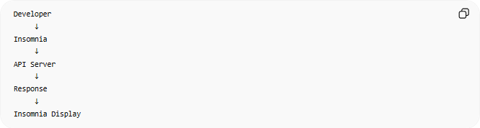
Developer
↓
Insomnia
↓
API Server
↓
Response
↓
Insomnia Display

⚖️ Insomnia vs Postman
# Source: AI Source: Provided by: [Data Path: Persons Table -> ID Column: 1, Name_En Column: Motasem Essam] -> From: [ChatGPT] on [6/2/2026]
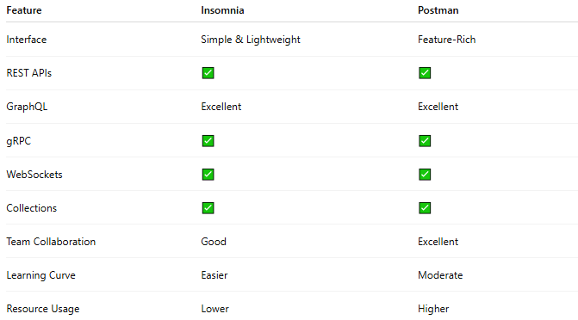
Feature | Insomnia | Postman
Interface | Simple & Lightweight | Feature-Rich
REST APIs | ✅ | ✅
GraphQL | Excellent | Excellent
gRPC | ✅ | ✅
WebSockets | ✅ | ✅
Collections | ✅ | ✅
Team Collaboration | Good | Excellent
Learning Curve | Easier | Moderate
Resource Usage | Lower | Higher

⚖️ Insomnia vs cURL
# Source: AI Source: Provided by: [Data Path: Persons Table -> ID Column: 1, Name_En Column: Motasem Essam] -> From: [ChatGPT] on [6/2/2026]
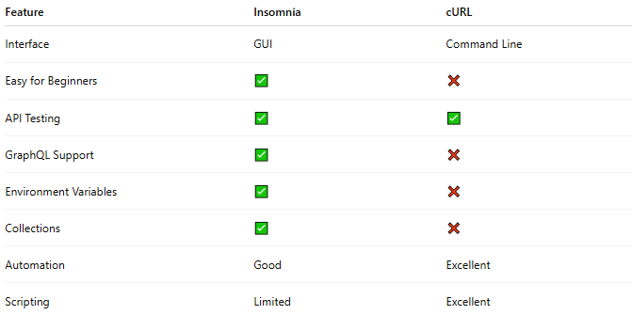
Feature | Insomnia | cURL
Interface | GUI | Command Line
Easy for Beginners | ✅ | ❌
API Testing | ✅ | ✅
GraphQL Support | ✅ | ❌
Environment Variables | ✅ | ❌
Collections | ✅ | ❌
Automation | Good | Excellent
Scripting | Limited | Excellent

🧠 Simple Analogy
# Source: AI Source: Provided by: [Data Path: Persons Table -> ID Column: 1, Name_En Column: Motasem Essam] -> From: [ChatGPT] on [6/2/2026]
Think of:
- cURL = direct command-line communication with an API 📞
- Insomnia = lightweight API workstation 🛠️
- Postman = full API management platform 🖥️
All three can send API requests, but Insomnia provides a cleaner and more focused interface than many larger API platforms.

Download Insomnia
# Source: ScreenShot Source: Provided by: [Persons Table -> ID Column: 1, Name_En Column: Motasem Essam] -> Tool: [Automation Table -> ID Column: 16, Name_En Column: Screen Capture] -> From [Site: Google Search: All: Insomnia] on [6/2/2026]
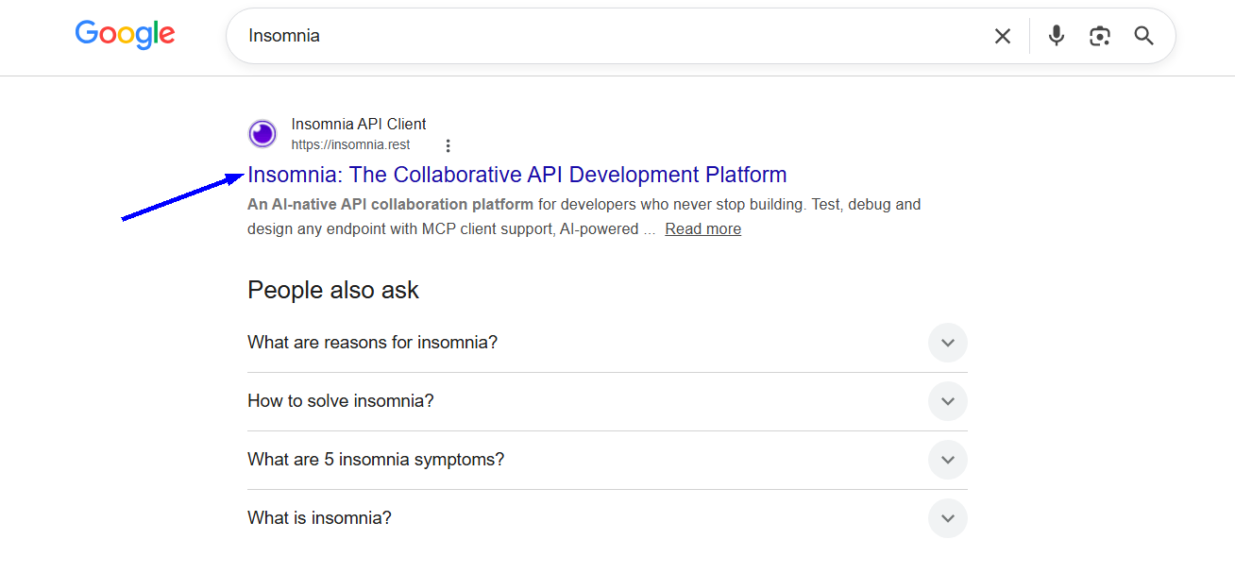
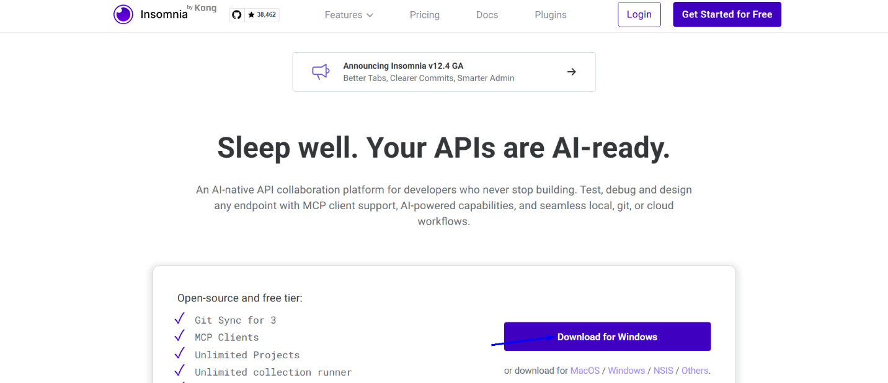

Install Insomnia
# Source: ScreenShot Source: Provided by: [Persons Table -> ID Column: 1, Name_En Column: Motasem Essam] -> Tool: [Automation Table -> ID Column: 16, Name_En Column: Screen Capture] -> From [Operating System: Windows] on [6/2/2026]
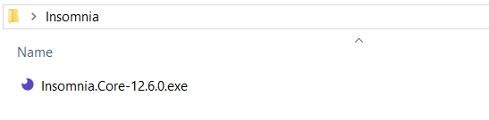


Run Insomnia
# Source: ScreenShot Source: Provided by: [Persons Table -> ID Column: 1, Name_En Column: Motasem Essam] -> Tool: [Automation Table -> ID Column: 16, Name_En Column: Screen Capture] -> From [Operating System: Windows] on [6/2/2026]
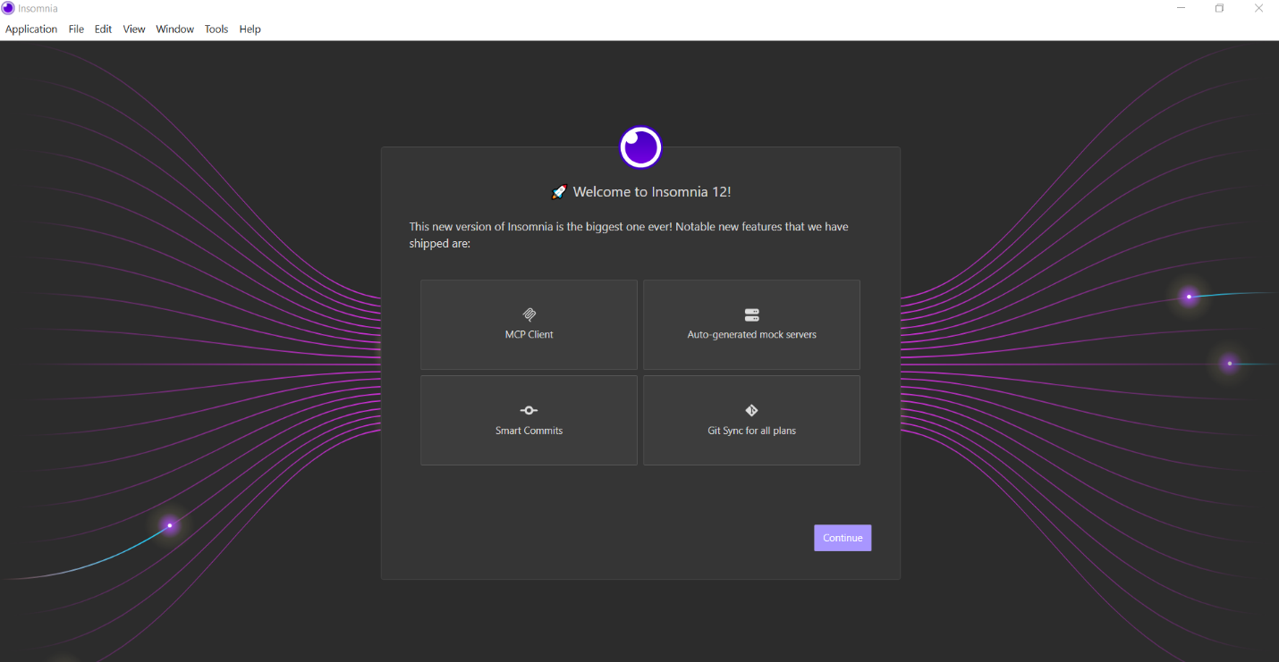

🧭 Summary
# Source: AI Source: Provided by: [Data Path: Persons Table -> ID Column: 1, Name_En Column: Motasem Essam] -> From: [ChatGPT] on [6/2/2026]
Insomnia is an API Development & Testing Platform that allows developers to send requests, test APIs, manage collections, use authentication, work with REST, GraphQL, gRPC, and WebSockets, and organize API workflows through a simple graphical interface. It is one of the most popular alternatives to Postman.

